|  |
| --- |
| Brigham Young University - Idaho |
| ECEN 250 – Lab 6 |
| Overall System - Operation, Measurements, and Lab Equipment |
|  |
|  |
| **9/29/2023** |

Table of Contents

Table of Figures 2

Objectives 3

Principles to Be Studied 3

Background 4

Procedures 4

Stereo Amplifier: Motherboard Jumpers and Daughterboard Header Pins 4

Playing Audio with Only the Buffer PCB 7

Verify Functionality 9

Mixing Audio with the Microphone {Buffer PCB and Mic. Preamp and Mixer PCB} 9

Verify Buffer PCB and Preamp & Mixer PCB Functionality 10

Complete Stereo Amplify with Treble and Bass {Buffer PCB, Mic. Preamp and Mixer PCB, and Treble & Bass PCB} 11

Verify Complete System Functionality {Buffer PCB, Mic. Preamp and Mixer PCB, and Treble & Bass PCB} 13

Measure Line Buffer Performance 14

Measure Microphone Preamp Circuit Performance 18

Measure Mixer Circuit Performance 19

Measuring the Treble and Bass Circuit Performance 21

Laboratory Cleanliness 25

Lab Report 25

Appendix A: Design Specifications 27

# Table of Figures

Figure 1 Logical Flow of Stereo Amplifier System 5

Figure 2 Stereo Amplifier Motherboard with Jumper Blocks (JB) and Daughterboard (DB) header pins highlighted. 6

Figure 3: Jumper Connection for playing audio with only the buffer PCB. 8

Figure 4 Audio In connections between audio jack and buffer input for both left and right channels explained. 8

Figure 5: Jumper configuration to connect Mixer PCB output directly to balance and bypassing Treble & Bass PCB 10

Figure 6: Jumper Configuration to Include Treble and Bass PCB. 12

Figure 7: Buffer - Signal Route (Input, Output pins, and Traces) 15

Figure 8 Buffer - function generator and oscilloscope connections for left channel 15

Figure 9 Buffer - function generator and oscilloscope connections for right channel 16

Figure 10 DC Blocking Cap (C15) on trace between Mic IN and Min on Preamp / Mixer PCB. 18

Figure 11 Preamp Signal Route (Input, Output pins, and Traces) 18

Figure 12 PreAmp - function generator and oscilloscope connections for first stage 19

Figure 13 PreAmp - function generator and oscilloscope connections for second stage 19

Figure 14 Mixer - Signal Route (Input, Output pins, and Traces) 21

Figure 15 Mixer - function generator and oscilloscope connections for left channel measurements 21

Figure 16 Mixer - function generator and oscilloscope connections for right channel measurements 22

Figure 17 Bass - Signal Route (Input, Output pins, and Traces) 23

Figure 18 Bass- function generator and oscilloscope connections for left channel measurements 23

Figure 19 Bass- function generator and oscilloscope connections for right channel measurements 24

Figure 20 Treble - Signal Route (Input, Output pins, and Traces) 24

Figure 21 Treble- function generator and oscilloscope connections for left channel measurements 25

Figure 22 Treble- function generator and oscilloscope connections for right channel measurements 25

Figure 23 – Station Drawer Organization 27

# Objectives

The objective of this laboratory is to provide you with a general overview of the series of labs and assessments you will be working on during the rest of the semester. You will receive circuit boards from students who completed the previous semester, and you will be expected to troubleshoot any issues and confirm that the boards adhere to the design requirements. The function generator and the oscilloscope, among other lab instruments, will be introduced to you. You will also learn how to use the stereo amplifier and how to take measurements with it.

# Principles to Be Studied

* High gain amplifier design
* Operational amplifier filter circuit design
* Voltage dividers and variable resistors
* Op-amp virtual short characteristics and input impedance
* Signal clipping
* High gain amplifier design

# Background

High quality stereo amplifiers have a very high input impedance (typically $1\text{M}Ω-20\text{M}Ω$). This high impedance reduces loading the signal source output stage. Driving the volume control directly with the line-in signal source is a low-quality design. Secondly, we would like to boost the signal slightly for our internal processing so that we have plenty of signal strength to drive the final amplifier stage to full output level. Lastly, what is a stereo without volume and balance controls?

The stereo system will feature microphone input, but this raises two problems: the microphone's input signal is very weak and needs to be amplified, and it only has one channel. The mixer will combine the single-channel signal into the left and right channels, and the pre-amp will take care of the first issue. The microphone and audio streams will have distinct and independent volume controls if the volume control module is placed before the mixer stage.

# Procedures

## Stereo Amplifier: Motherboard Jumpers and Daughterboard Header Pins

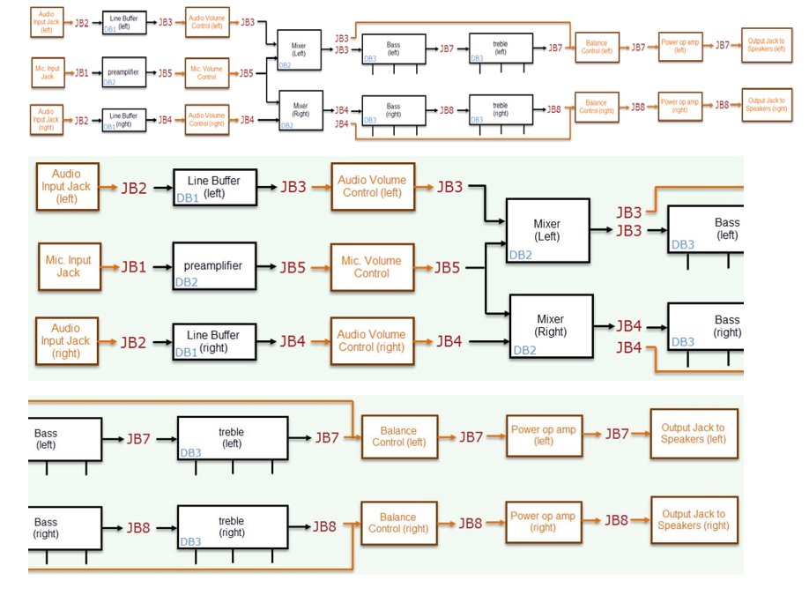

Figure 1 Logical Flow of Stereo Amplifier System

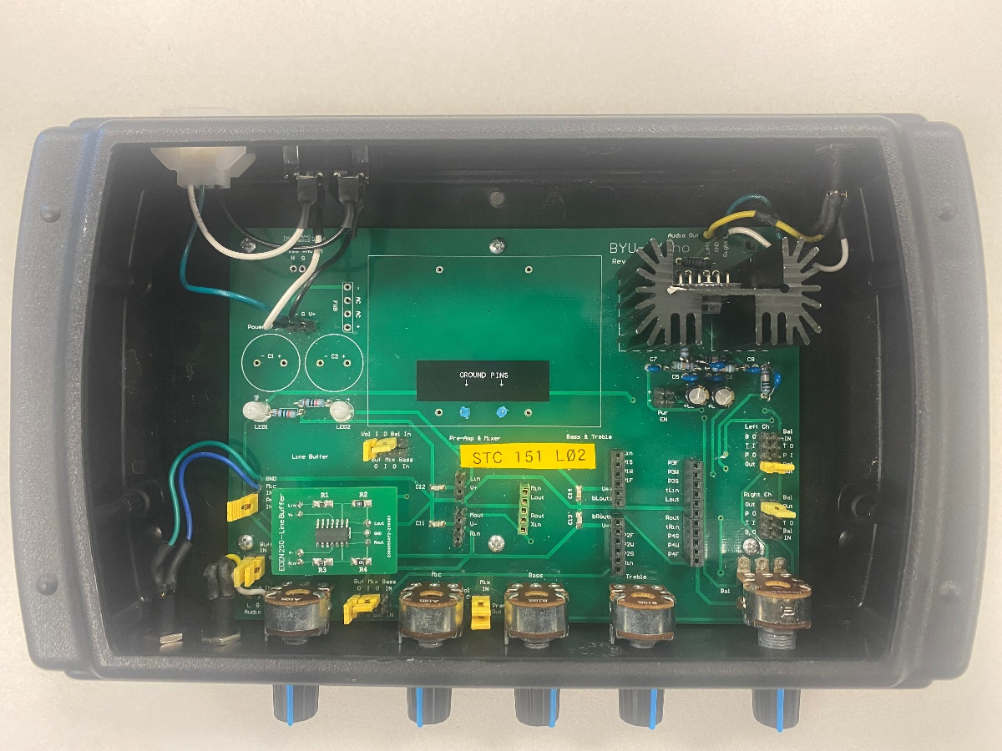 (a)

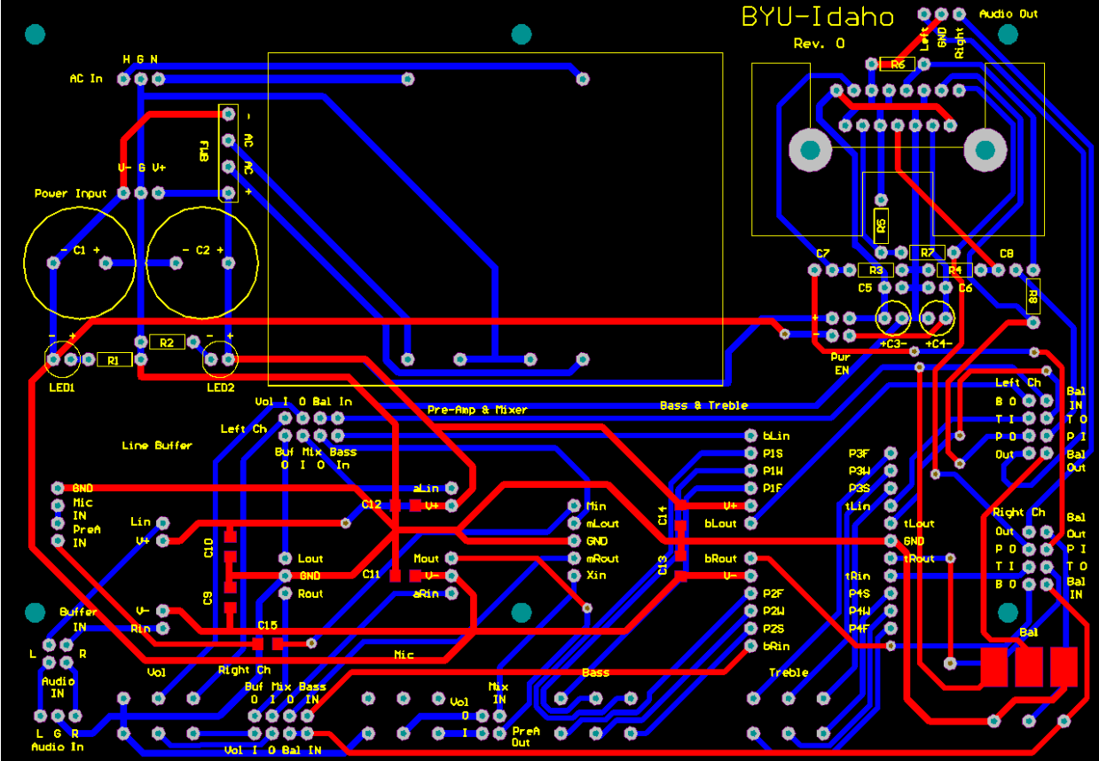(b)

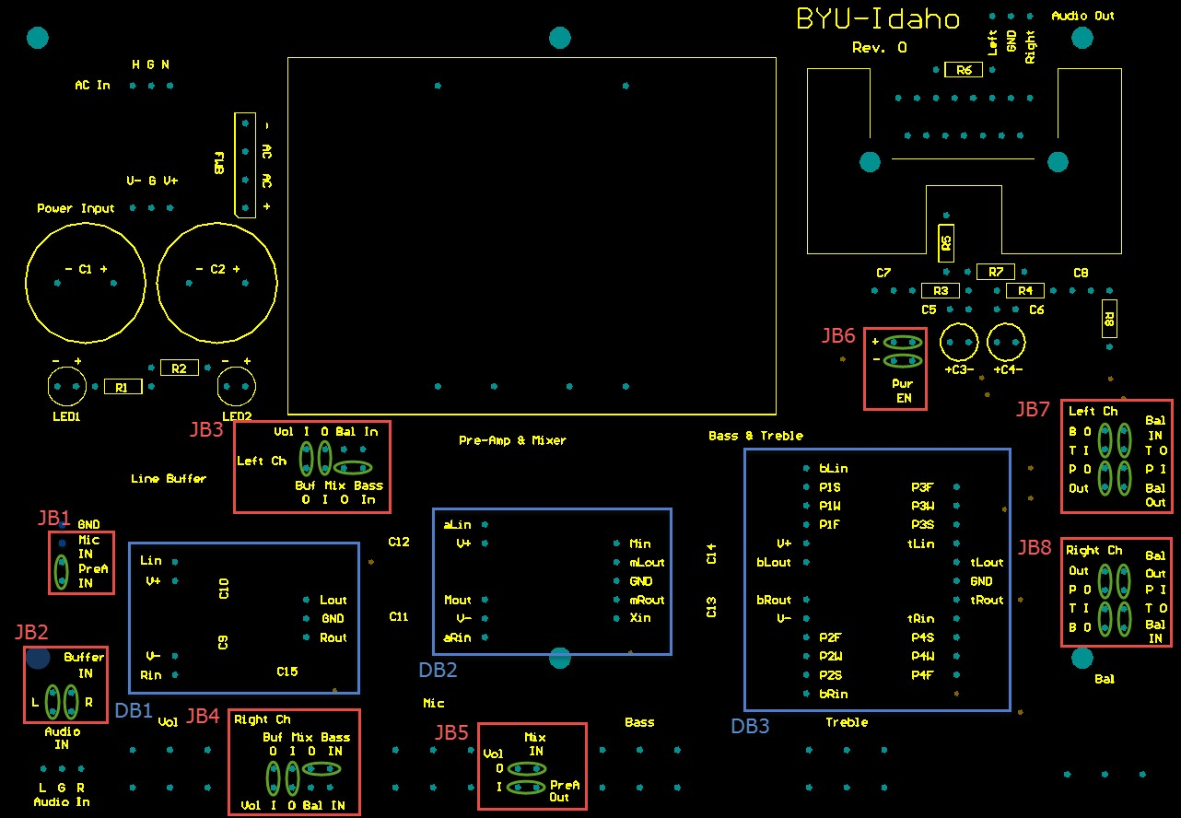(c)

Figure 2 Stereo Amplifier Motherboard with Jumper Blocks (JB) and Daughterboard (DB) header pins highlighted.

Make sure you can identify the regions labelled JB1 to JB8 and DB1 to DB3 in Figure 2. The region JB1 to JB8 are for jumper connections and DB1 to DB3 are slots to insert the daughter PCB boards.

Note: JB6 shows jumpers to connect power to the power amplifier. Since we are using powered speakers, we will bypass the power amplifier, so these connections are not needed.

To understand the basic operation of the stereo amplifier, watch the following video.

Video: [Overall System Operation](https://www.youtube.com/embed/U4kqyP2bigg?feature=oembed)

We will first verify the functionality of each of the daughter PCBs {Buffer PCB, Mic. Preamp & Mixer PCB, Treble & Bass PCB} after which we will go back and take specific measurements to determine how well they perform.

# Playing Audio with Only the Buffer PCB

To verify the functionality of the Buffer PCB, we will route an audio signal through the Buffer PCB and then to the audio volume control, and finally to the speakers. Figure 3 shows all the needed jumper connections.

To start, identify the location of the audio jack on the front of the chassis. You can trace its connection to Audio IN (Just below JB2) on the board. Make the jumper connections to connect the audio in Left and Right channels to the Buffer In Left and Right channels respectively has shown in JB2 of Figure 3. To remove the connectors, you can use the needle nose pliers in the drawer.



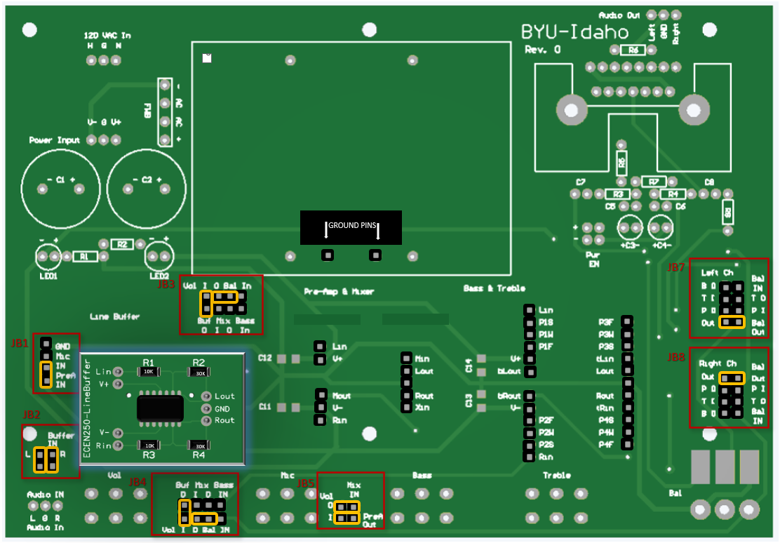

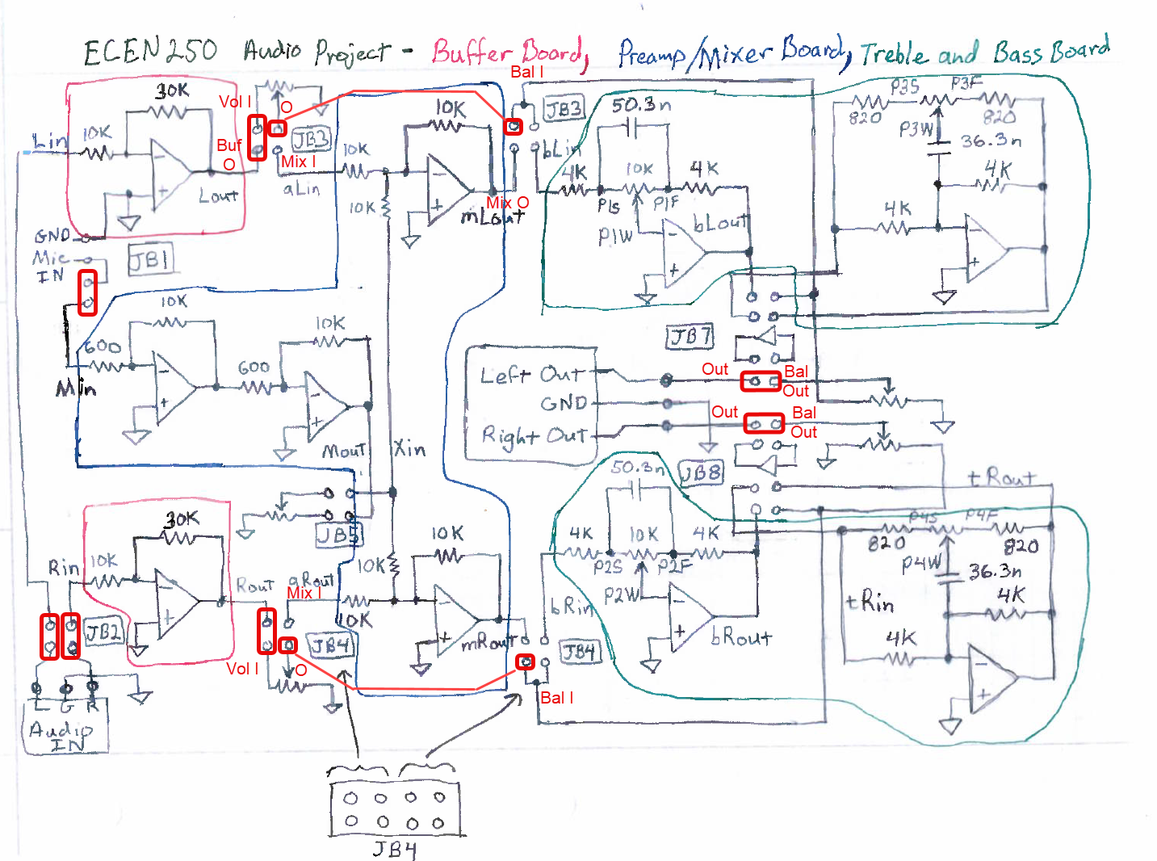

Figure 3: Jumper Connection for playing audio with only the buffer PCB.

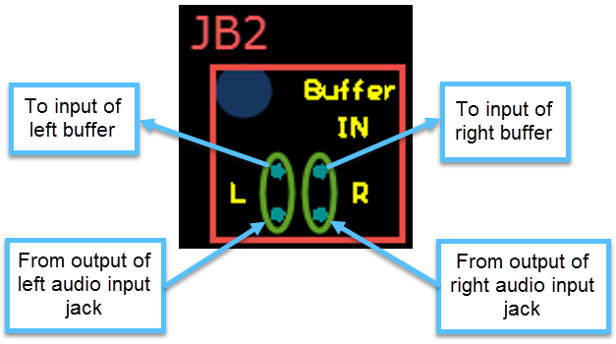

Figure 4 Audio In connections between audio jack and buffer input for both left and right channels explained.

The output of the line buffer (Buf 0) connects to region JB3 (Left) and JB4 (Right) as illustrated in Figure 3. The output (Buf O) from the left buffer is connected to the input of the volume control (Vol I). Note, we can make a connection from the output of the volume control to the input of the mixer (Mix I) or bypass the mixer and go straight to balance control. In this section, we bypass the mixer and route the signal straight to the balance control by connecting the output of the audio volume control (Vol O) to the input of the balance control (Bal). Finally, as seen in region JB7 and JB8, the output of the balance control for both the left and right channels respectively is connected to (Out) which is the input to the speakers.

*Note that JB1 and JB5 connections will have no effect on the Buffer PCB because the Preamp and Mixer PCB are not connected, and the signals are routed to bypass this board include the treble and bass boards.*

You may now insert your buffer board into the Line Buffer slot of the chassis if you haven’t done so already. You can power the board by plugging in the power chord into the chassis and into an outlet. Connect the speakers at the back of the chassis and use the 1/8” stereo audio cable provided to connect to the Audio IN in front of the chassis on one end and into the lab computer on the other end of the cable. Play a song on the lab computer. To play a song, you may browse to this link [Come, Thou Fount of Every Blessing (2011) | The Tabernacle Choir – YouTube](https://www.youtube.com/watch?v=gPKpkrqBwNs&list=RDQM7-VT9ODbemU&start_radio=1). Verify that you can hear the song playing out of the connected speakers.

## Verify Functionality

* What does the audio volume knob do when you turn it? Does it work as expected?
* What does the balance control knob do when you turn it? Does it work as expected?

# Mixing Audio with the Microphone {Buffer PCB and Mic. Preamp and Mixer PCB}

We will now verify the functionality of the Microphone Preamp and Mixing PCB. With the power turned off, connect the header jumpers in accordance with Figure 5. Note that “Mic In” is connected to “PreA IN” (see JB1). The microphone signal is then amplified and the amplified output at “PreA Out” (see JB5) is connected to the Mic ‘Vol I’ which goes to the input to the potentiometer. The jumpers in region JB3 and JB4 are modified to incorporate the Pre-Amp and Mixer into the system.

Connect the pre-amp and mixer PCB into its proper header pins (make sure the line buffer is also plugged in). Connect the microphone, powered speakers, and an audio source to the jacks on the chassis. Ensure that the ‘Bal Out’ pins are still connected to the ‘Out’ pins in JB7 and JB8. With the two different volume knobs on the chassis, you should be able to manage the microphone volume separately from the audio volume.

## Verify Buffer PCB and Preamp & Mixer PCB Functionality

* Does the microphone volume knob control the volume of the microphone coming out of the speakers?
* Does the microphone come out of both the left and right speakers?
* Does the audio volume knob control the volume of the audio coming out the speakers?
* Does the audio signal come out of both the left and right speakers?
* Do the microphone and the audio signals mix and come out of both the left and right speakers?
* Does the balance knob change the percentage of sound coming out of the left and right speakers?
* 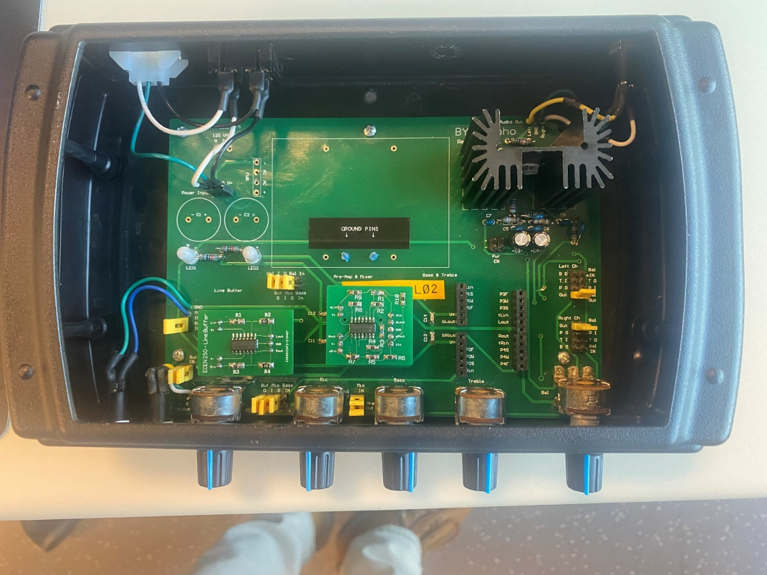

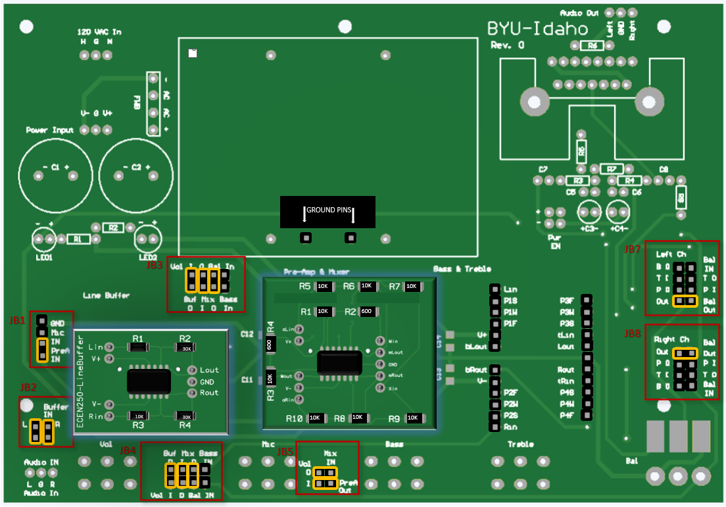

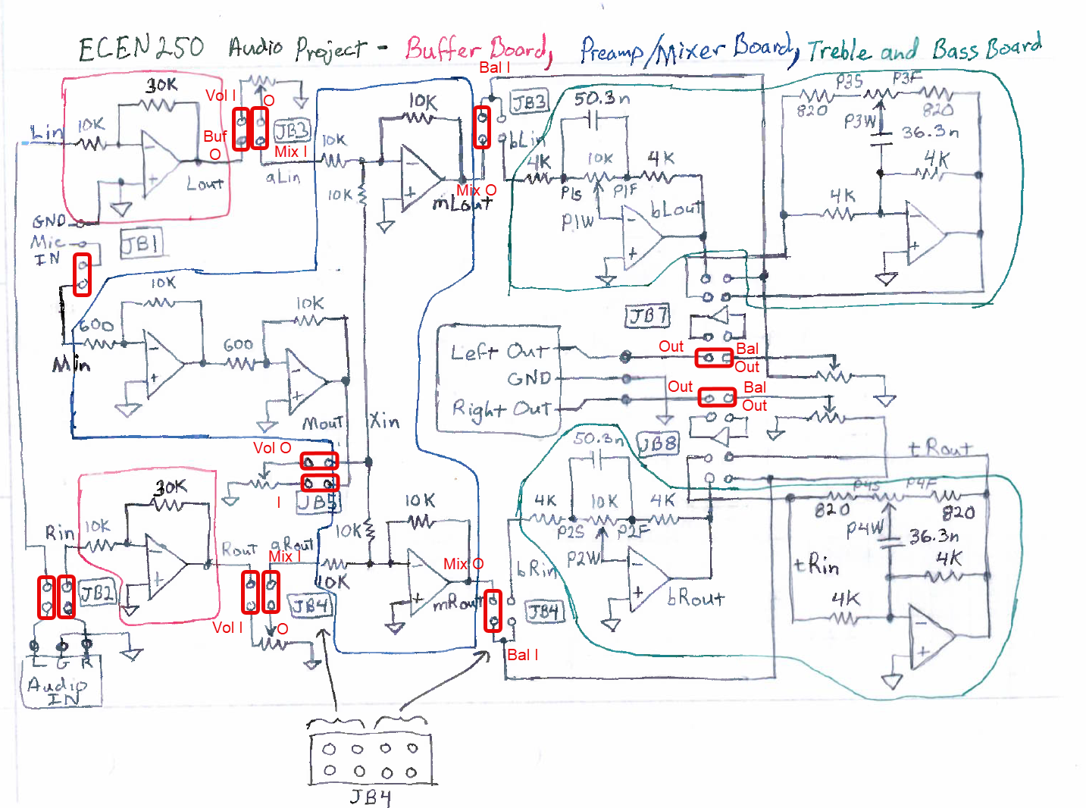

Figure 5: Jumper configuration to connect Mixer PCB output directly to balance and bypassing Treble & Bass PCB

# Complete Stereo Amplify with Treble and Bass {Buffer PCB, Mic. Preamp and Mixer PCB, and Treble & Bass PCB}

To verify the functionality of the Treble & Bass PCB, we will now connect the treble and bass PCB (with the power turned off) to the stereo amplifier by plugging the board into the proper slots to integrate it with the rest of your system (make sure the line buffer and preamp PCBs are also plugged in). Set the jumpers to route the signal appropriately as shown in Figure 6.

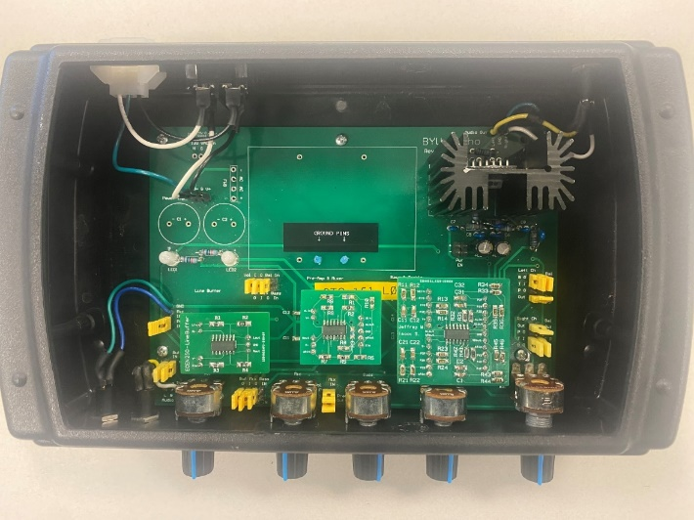

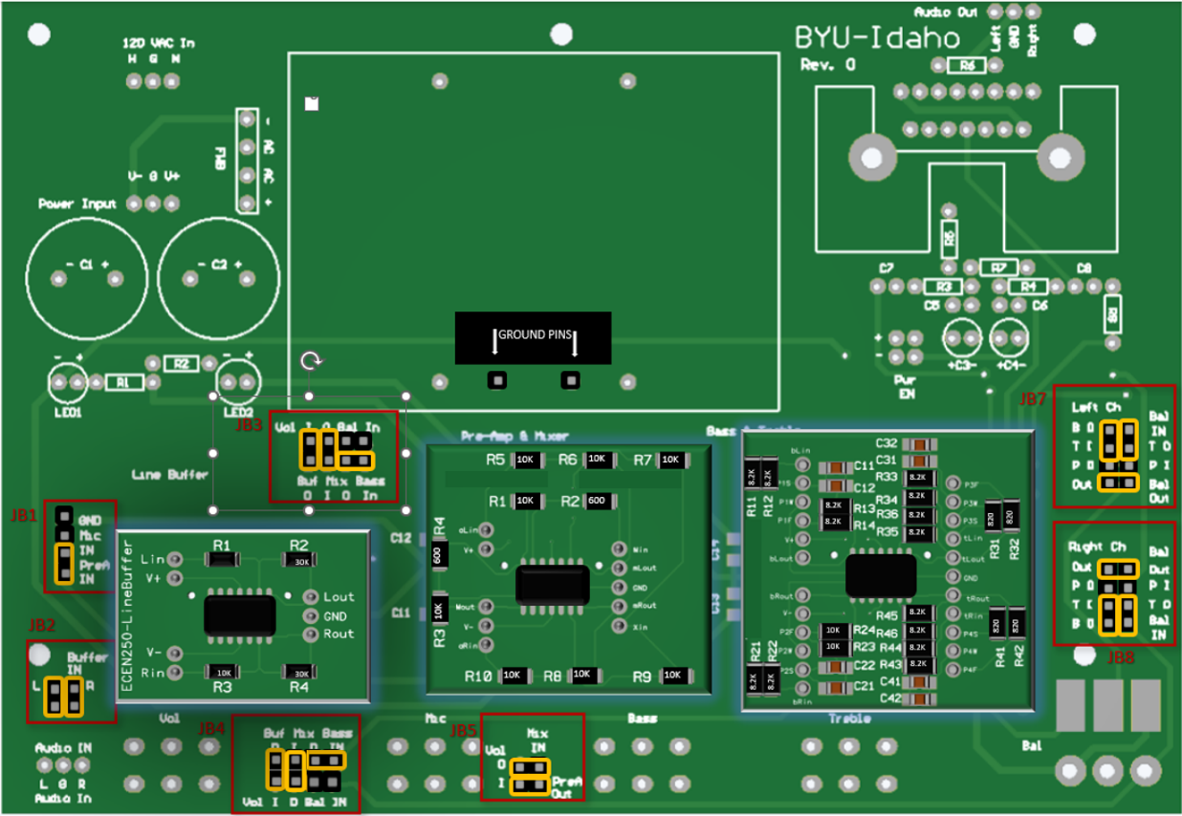

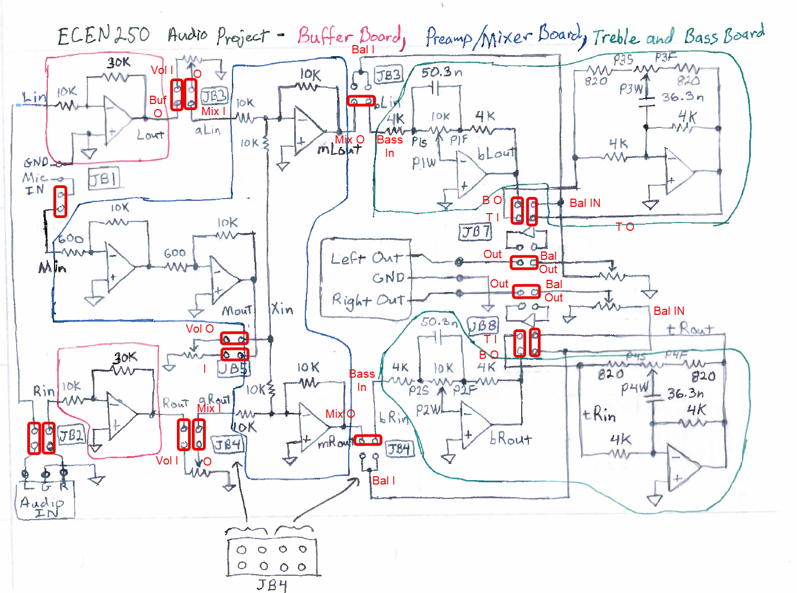

Figure 6: Jumper Configuration to Include Treble and Bass PCB.

# Verify Complete System Functionality {Buffer PCB, Mic. Preamp and Mixer PCB, and Treble & Bass PCB}

* Can you hear low frequencies being attenuated or boosted when the bass knob is turned fully counterclockwise or fully clockwise?
* Can you hear high frequencies being attenuated or boosted when the treble knob is turned fully counterclockwise or fully clockwise?
* Does the microphone volume knob control the volume of the microphone coming out of the speakers?
* Does the microphone come out of both the left and right speakers?
* Does the audio volume knob control the volume of the audio coming out the speakers?
* Does the audio signal come out of both the left and right speakers?
* Do the microphone and the audio signals mix and come out of both the left and right speakers?
* Does the balance knob change the percentage of sound coming out of the left and right speakers?

# Measure Line Buffer Performance

Now we will measure the performance of the buffer PCB. Note that you will be performing a similar test on your own buffer PCB in the future so you can refer to these instructions later.

Start by turning off the power and removing the Preamp & Mixer PCB as well as the Treble and Base PCB (if they are in the Cassis) and set up the chassis as it was done to in the “Play Audio with Only the Buffer PCB” section.

Since you will need to use an oscilloscope to take the measurements, watch the following video to learn some basic principles.

Video: [Oscilloscope Basic Principles](https://www.youtube.com/watch?v=8Awty-VTVfY&t=5s)

You are going to evaluate the performance of the buffer by measuring the gain of the audio amplifier. You will use the function generator that can inject a test signal at the amplifier input. Connect two oscilloscope channels to the amplifier input and output. Measure both signal levels and use the measurements to calculate the gain.

The following video will show the basics for connecting the function generator and the oscilloscope to the buffer PCB in the audio amplifier chassis.

Video: [Buffer Line Measurements](https://www.youtube.com/embed/Y1AeLhJyXmg?feature=oembed)

To test this board while it is plugged into the motherboard, use the left or right Buffer In pin for the input signal shown in the bottom left circle above and the Buf O (Left = top, Right = bottom) as the output shown in the two circles just to the right. Then use the function generator as your input signal and connect the output to the oscilloscope as explained below.

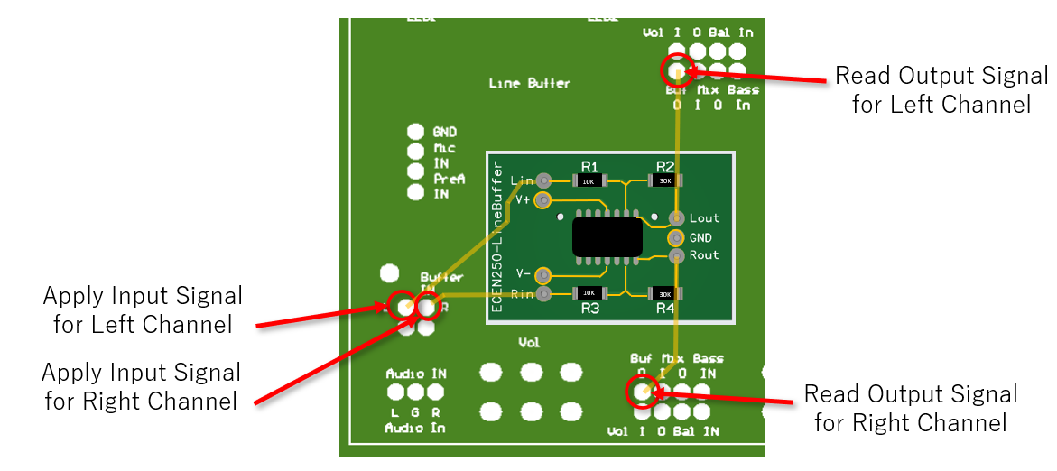

Figure 7: Buffer - Signal Route (Input, Output pins, and Traces)

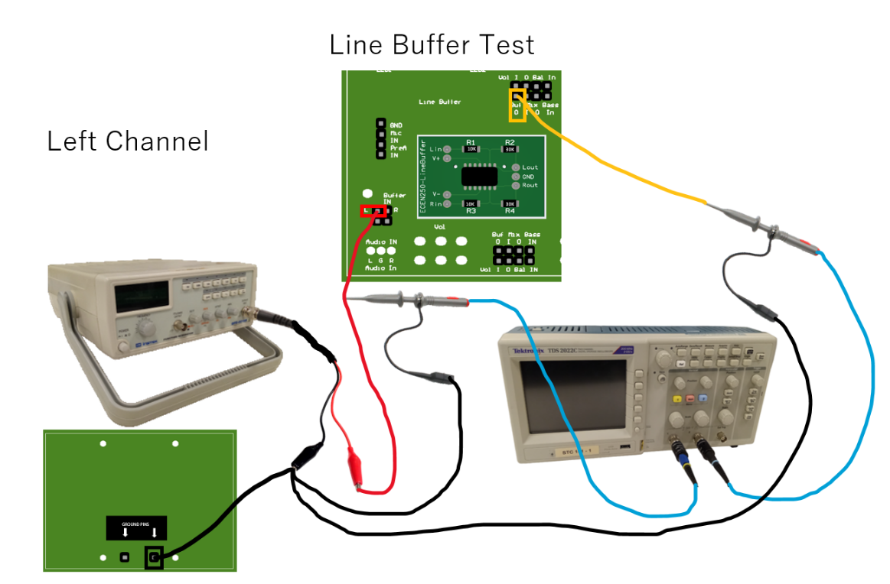

Figure 8 Buffer - function generator and oscilloscope connections for left channel

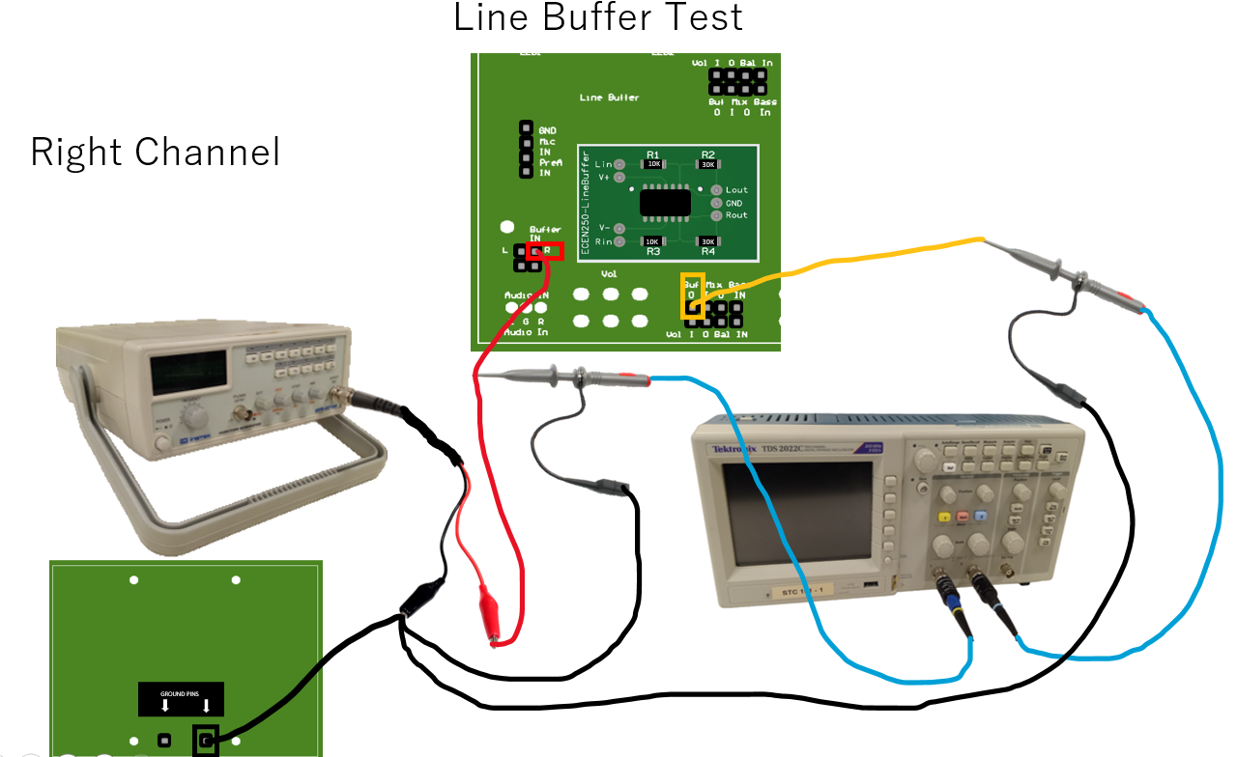



Figure 9 Buffer - function generator and oscilloscope connections for right channel

Your “in-circuit” tests should emulate the simulations performed in PADS Pro Designer completed in Lab 2. Create a $2V_{pp}$ sinusoidal signal with the function generator and use this as your input voltage. The function generator has only one sinusoidal output, so you will only be able to test one channel at a time. Using an oscilloscope, keep one oscilloscope probe on the input and use the other probe to verify the output voltage. Use the “Buffer In” header upper pins (furthest away from front panel) along with female-to-male DuPont cables to connect the input signals (you should remove the 0.1 in header shunts). Use the “Buf O,” header pin as appropriate to probe the output.



Take screenshots of appropriate oscilloscope measurements. Use Table 1 as a guide to verify the amplifier’s operation and include it in your lab report. Your screenshots (4 screenshots in total) and table should show that the given design meets the specifications given in Appendix A under Line Buffer Amplifier. Include a Caption of the table and each screenshot.

Table 1 – Frequency Response

|  |  |  |  |  |
| --- | --- | --- | --- | --- |
| $V_{in}=2V_{pp}$**from Function Generator** | **Frequency** | $$V_{in\left(pp\right)}$$ | $$V_{out\left(pp\right)}$$ | **Gain $\left(A=\frac{V_{out\left(pp\right)}}{V_{in\left(pp\right)}}\right)$** |
| **Right**  **Channel** | **20 Hz** |  |  |  |
| **Right**  **Channel** | **20 kHz** |  |  |  |
| **Left**  **Channel** | **20 Hz** |  |  |  |
| **Left**  **Channel** | **20 kHz** |  |  |  |

Video: [Line Buffer Schematic and Gain](https://youtu.be/Yo8Gl-WSdwM)

With Table 1 completed and included in your report, you can now verify if the frequency response meets specifications. Calculate the maximum deviation of the output voltage over frequency with the equation below. Does the given circuit meet frequency response specifications as given in Appendix A?

$$Deviation \left(dB\right)=20∙\log_{10}\left(\frac{V_{out\left(max\right)}}{V_{out\left(min\right)}}\right)$$

## Measure Microphone Preamp Circuit Performance

Video: [Preamp Measurements](https://www.youtube.com/embed/NWjPNdktnYM?feature=oembed)

To perform the measurements, start by removing the buffer and plugging in the Preamp & Mixer PCB. The header pins you need to access are in JB1 and JB5 for the input and out of the preamp respectively.

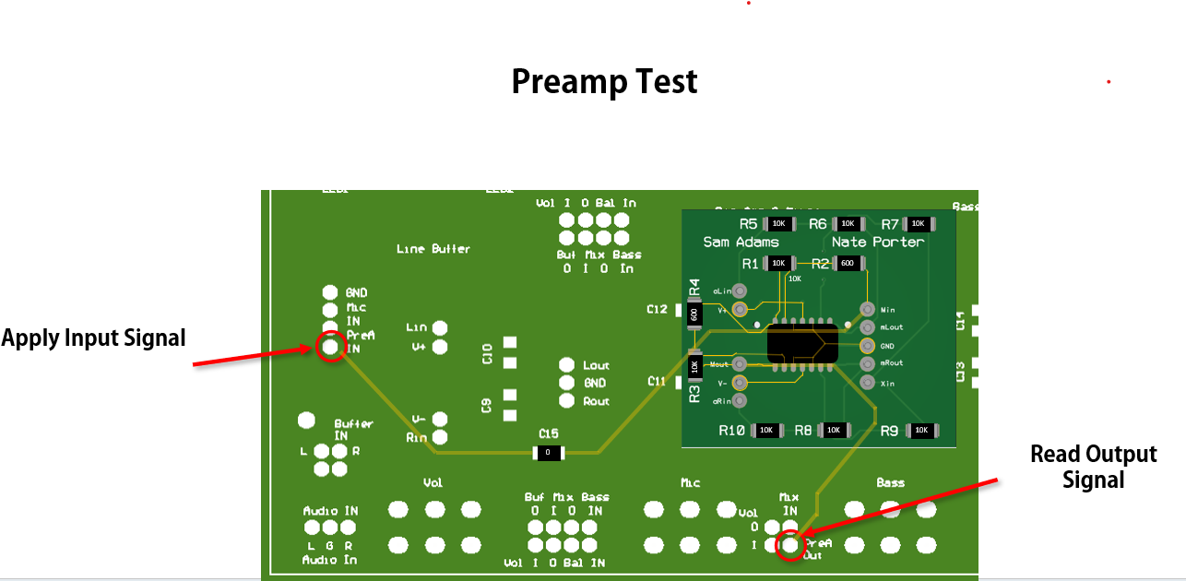

Figure 11 Preamp Signal Route (Input, Output pins, and Traces)

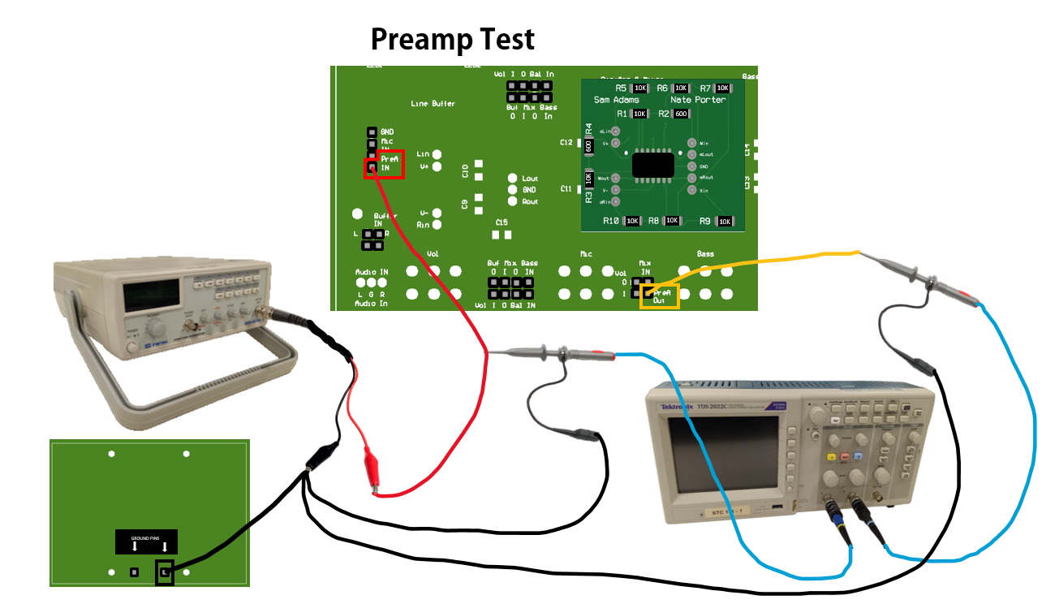

## Measure Mixer Circuit Performance

Video: [Mixer Measurements](https://www.youtube.com/embed/UWyLUZUeuMw?feature=oembed)

Use the same input signal for the microphone and audio inputs to assess the mixer's performance. Given that the input signals are the same, the output signal should be the sum of the two input signals, the output voltage should be twice as high as the input signal.



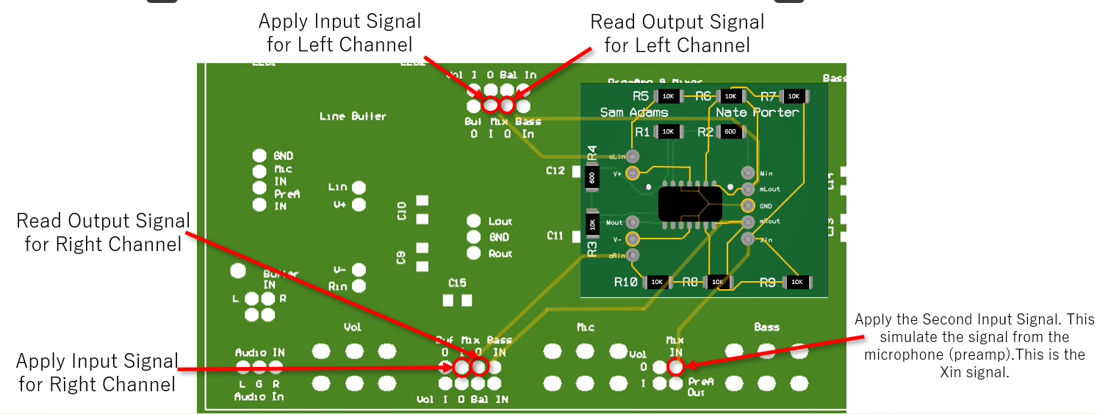

Figure 14 Mixer - Signal Route (Input, Output pins, and Traces)

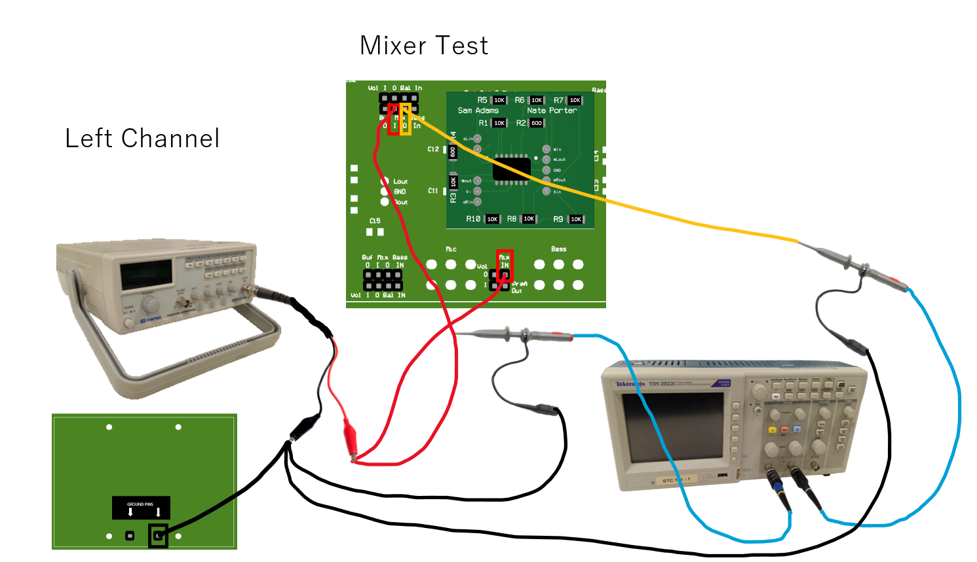

Figure 15 Mixer - function generator and oscilloscope connections for left channel measurements

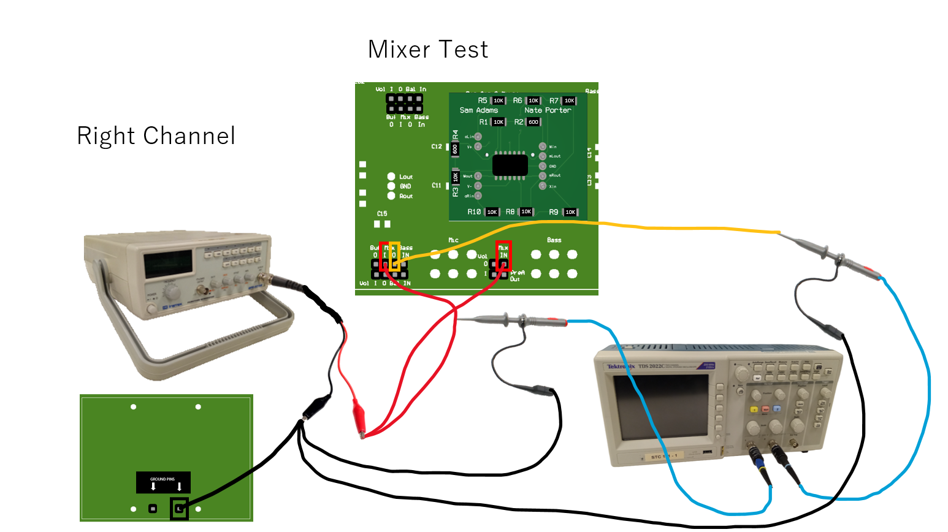

Figure 16 Mixer - function generator and oscilloscope connections for right channel measurements

Complete *Table 2* to help you verify that the circuit meets the frequency response specifications. Include 3 screenshots of the oscilloscope (3 out of the 6 measurements) and the completed Table 2 in your report.

|  |  |  |  |  |
| --- | --- | --- | --- | --- |
| **Amplifier** | **Frequency (Hz)** |  |  | **||** |
| **Pre-Amp** | $$20$$ |  |  |  |
| $$20k$$ |  |  |  |
| **Mixer Left Channel** | 20 |  |  |  |
| $$20k$$ |  |  |  |
| **Mixer Right Channel** | 20 |  |  |  |
| $$20k$$ |  |  |  |

Table 2: Pre-Amp and Mixer Frequency Response

Video – Chapter Mixer Schematic & Gain (3:05): [Calculating the Gain of the Preamp and Mixer Circuits](https://youtu.be/pb7mhec1x0k)

# Measuring the Treble and Bass Circuit Performance

To measure the Treble and Bass Circuit Performance, start by removing the Preamp & Mixer PCB and plugging in the Treble & Bass PCB.

You will need to take measurements of the left and Right Bass circuits channels and the left and right Treble circuit channels as shown in Figure 18, Figure 19, Figure 21, and Figure 22.

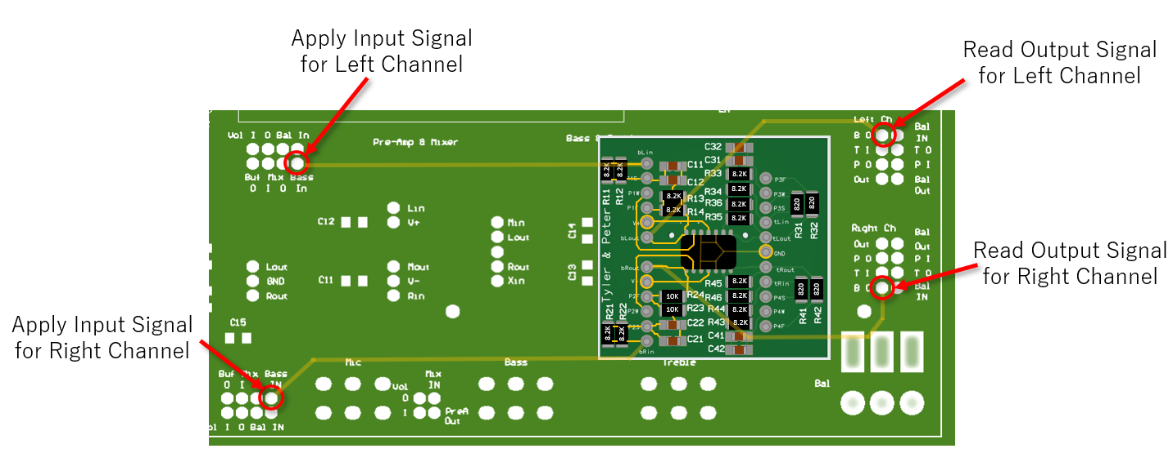

Figure 17 Bass - Signal Route (Input, Output pins, and Traces)

Video: [Setup for Measuring the Bass Circuit Performance](https://www.youtube.com/embed/VIKnpEFqTpo?feature=oembed)

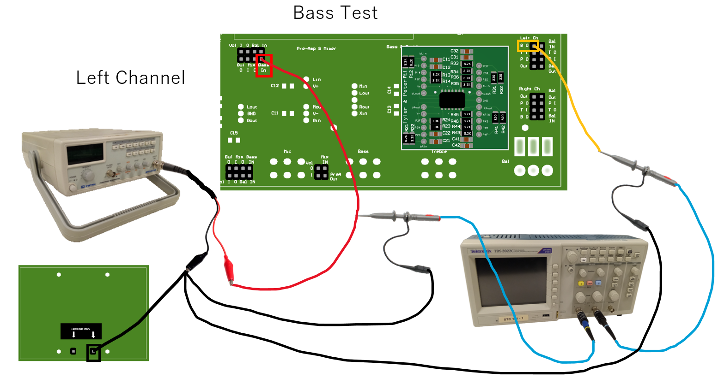

Figure 18 Bass- function generator and oscilloscope connections for left channel measurements

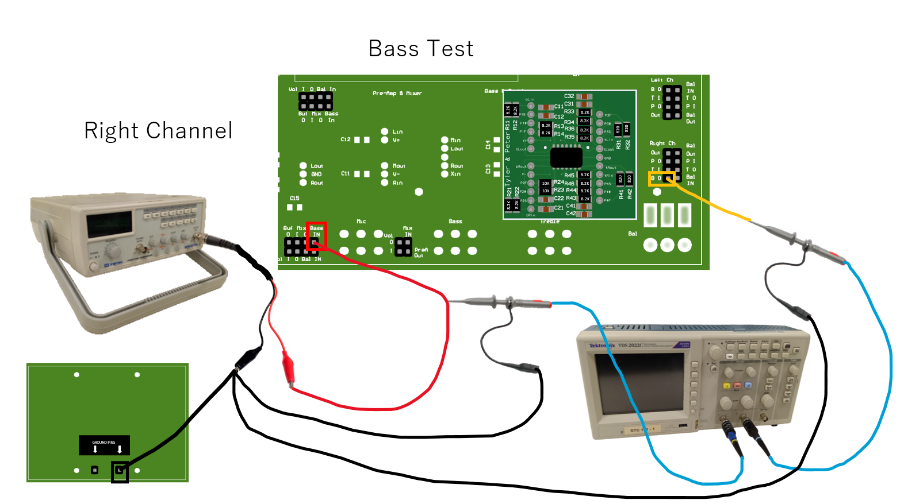

Figure 19 Bass- function generator and oscilloscope connections for right channel measurements

Video: [Setup for Measuring the Treble Circuit Performance](https://www.youtube.com/embed/r8usDo7e_6M?feature=oembed)

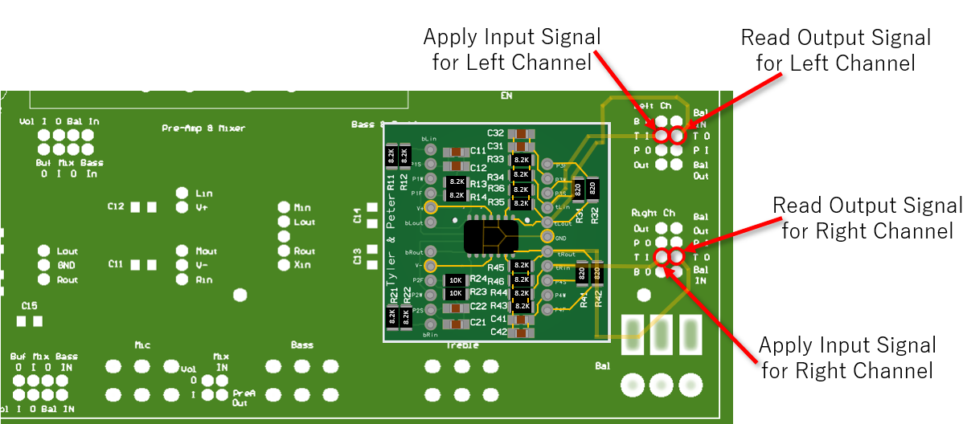

Figure 20 Treble - Signal Route (Input, Output pins, and Traces)

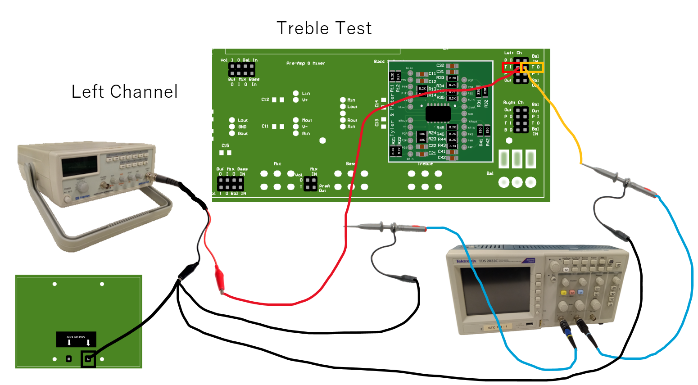

Figure 21 Treble- function generator and oscilloscope connections for left channel measurements

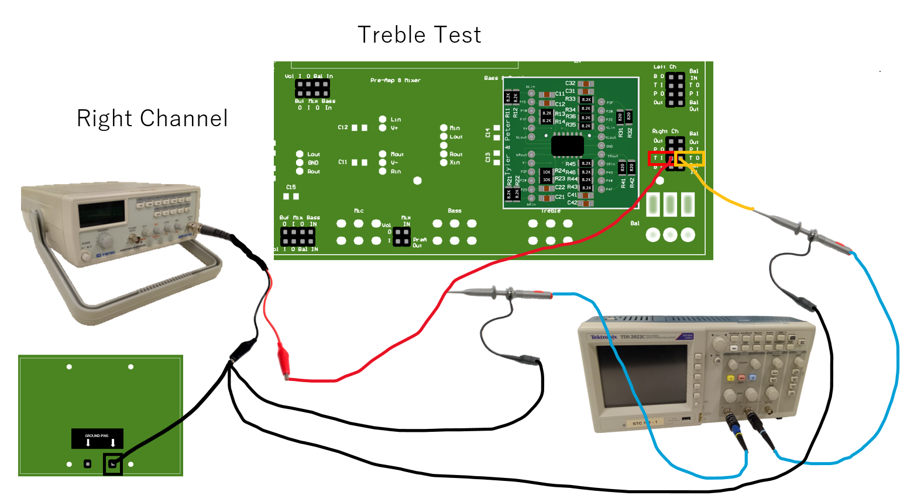

Figure 22 Treble- function generator and oscilloscope connections for right channel measurements

Complete Table 3 and verify if the circuit meets the design specifications. To complete Table 3, $α=0$ means that the treble or the bass knob is turned all the way to the left and $α=1$ implies that the bass or treble knob is turn all the way to the right. Oscilloscope screenshots to include: Treble -> Low and High Frequency when $α=0$ and $α=1 \left(4 screenshots in total\right)it be either left or right channel not both. Bass -> Low and High Frequency when α=0 and α=1 \left(4 screenshots in total\right).$

Table 3 Treble and Bass Frequency Response Measurements.

|  |  |  |  |  |  |  |  |  |
| --- | --- | --- | --- | --- | --- | --- | --- | --- |
|  | **Channel** | $$f(Hz)$$ | **Treble** | | | **Bass** | | |
|  |  |  |  |  |  |
|  | **Left** | $$20Hz$$ |  |  |  |  |  |  |
| $$20kHz$$ |  |  |  |  |  |  |
| **Right** | $$20Hz$$ |  |  |  |  |  |  |
| $$20kHz$$ |  |  |  |  |  |  |
| $$α=1$$ | **Left** | $$20Hz$$ |  |  |  |  |  |  |
| $$20kHz$$ |  |  |  |  |  |  |
| **Right** | $$20Hz$$ |  |  |  |  |  |  |
| $$20kHz$$ |  |  |  |  |  |  |

Video: [Treble & Bass Schematic and Gain](https://youtu.be/B5oWEN8xflk)

# Laboratory Cleanliness

You have been assigned a specific lab bench and stereo kit. You are responsible for them throughout the semester. Since this is the first lab in which you use equipment from the drawer, you will have to pass-off a clean, organized station at the end of this lab. Every station’s top drawer has a black organizer with 7 slots and pictures of what goes where as shown in Figure 23. If any of the items are missing, you must make note of it and notify an assistant at the time of sign-off, or in your Lab Report. Although you will not be required to pass-off the station in the future, you may still be deducted points if your station or equipment state is unacceptable. Consider this pass-off as an oportunity to strengthen your sense of responsibility and stewardship over the sacred resources we have available on this campus. INCLUDE A PICTURE OF YOUR LAB BENCH, THE INSIDE OF THE DRAWER, AND THE LAB KIT HOLDING THE SPEAKERS. If you are doing these labs remotely, take a picture of your put-away lab kit, soldering kit, and any other materials sent to you. Any lost equipment may be charged to you at the end of the semester.

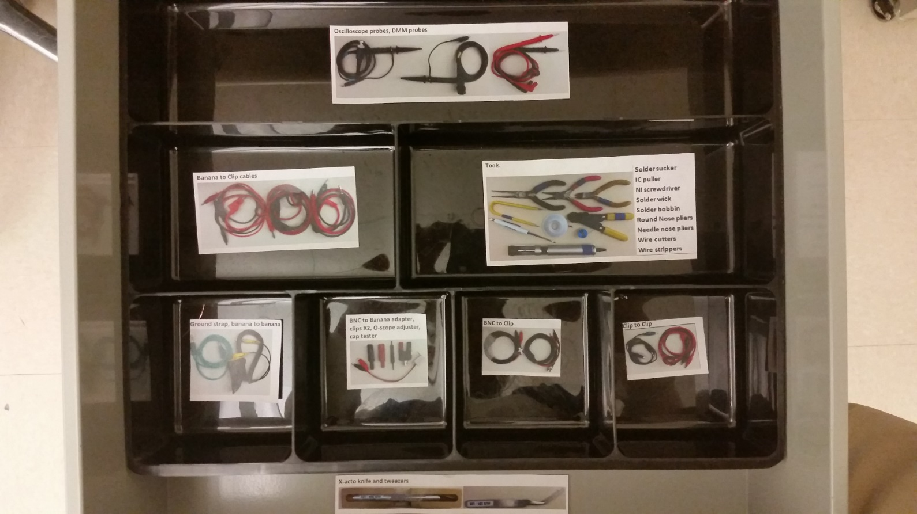

Figure 23 – Station Drawer Organization

# Lab Report

Your lab report should focus on the physical measurements you took in the lab, centered on Table 1, 2, and 3 and interpret what they mean. But do remember to briefly comment about any screenshots included (they should be properly labeled and referenced) and about anything that was marked red or highlighted in green in the instructions. In your conclusions, indicate what issues you ran into and how you were able to overcome/fix those issues. Include things you learned in the design process. Also include a summary of the design specifications, if they were met or not, and why. If they were not met, what would you do (if you had the resources) to meet the design specifications. The grading rubric is shown below and on I-Learn.

|  |  |
| --- | --- |
| **Grading Rubric** | |
| **Worth** | **Description** |
| 10 | Lab report format (see I-Learn) |
| 20 | Verification questions answered with explanations |
| 40 | Design specifications were measured.   * Tables 1 to 3 with Oscilloscope Figures (35 pts) * Deviation equation (5pts) |
| 10 | Conclusion: Were design specifications met with explanation? |
| 10 | Organized drawer picture |
| 10 | Grammar and Professionalism |
| **100** | **Total** |

# Appendix A: Design Specifications

**Line Buffer Amplifier**

* Voltage gain ($A$): $-3$, nominal. That is, ${\left|A\right|}_{db}=20\log{|-3|}=9.5 \text{dB}$ nominally.
* Frequency response: $\left|{\left|A\left(f\right)\right|}_{\text{dB}}-9.5 \text{dB}\right|≤3 \text{dB}$ where $20 \text{Hz}≤f≤20 \text{kHz}$

**Pre-Amp and Mixer**

$A_{V\left(\text{pre-amp}\right)}=277±10\%$

* Frequency Response: Within $±3dB$ for $20Hz≤f≤20kHz$

**Bass**

* For $f≤20Hz$: $+10 \text{dB}$ minimum Boost & $-10 \text{dB}$ maximum Cut
* For $f≥1kHz$: $+3 \text{dB}$ maximum Boost & $-3 \text{dB}$ minimum Cut
* For $20 \text{Hz}≤f≤20 \text{kHz}$ and at mid Bass setting: $+1 \text{dB}$ max. Boost & $-1 \text{dB}$ min. Cut

**Treble**

* For $f≥20 \text{kHz}$: $+12 \text{dB}$ minimum Boost & $-12 \text{dB}$ maximum Cut
* For $f≤1 \text{kHz}$: $+3 \text{dB}$ maximum Boost & $-3 \text{dB}$ minimum Cut
* For $20 \text{Hz}≤f≤20 \text{kHz}$ and at mid Treble setting: $+1 \text{dB}$ max. Boost & $-1 \text{dB}$ min. Cut